**Proportion in Equilibrium Graphs**

It is important that any changes shown when completing equilibrium graphs are shown proportionally correct.

Two aspects need to be considered:

1. The effect of the original change
2. The changes that occur as the system returns to equilibrium

For Example:

Ammonia is produced according to the following reaction:

https://www.chemguide.co.uk/physical/equilibria/habereq.gif

In a reaction vessel the following was conducted:

* Nitrogen and hydrogen were added to a vessel, then the mixture was allowed to reach equilibrium (T1).
* At a later time (T2), the reaction vessel was compressed, then allowed to reach equilibrium again (T3).

This can be represented by the following graph:

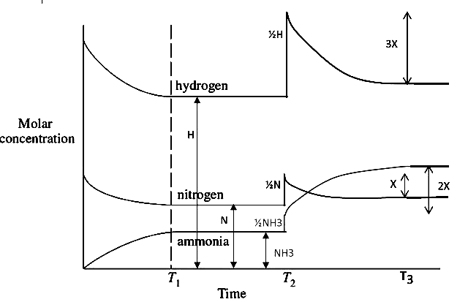

The following important points are shown:

Initial Change (T2):

* The initial jump in concentration depends on the equilibrium concentrations at the time of compression (not the stoichiometric ratios).
* According to Boyles law P = 1/V, decreasing volume of the vessel increases the partial pressure of each gases, and therefore (according to Avogadro’s law) the molar concentration
* Each gas concentration must jump by the same percentage. If the hydrogen concentration increases by half its value (1/2H on the picture), then nitrogen and ammonia must jump by half their original value (see the diagram above)
* Therefore, if the reaction volume was halved the concentrations of each would be double the original concentration of each.

Shift towards Equilibrium (T2-T3):

* Once the equilibrium shifts, each gas must change according to their mole ratio in the equation (stoichiometric ratios). For example, for every 1x change in mitogen there will be a 2x change in ammonia and 3x change in hydrogen. (see diagram above).
* When equilibrium is reached (T3) the concentrations of reactants (N2 and H2) will still be slightly higher than the starting concentrations.

The initial proportional change also needs to be considered if the reaction vessel was allowed to expand (pressure decreased), and when graphing equilibrium involving diluting a solution (see diagram below):

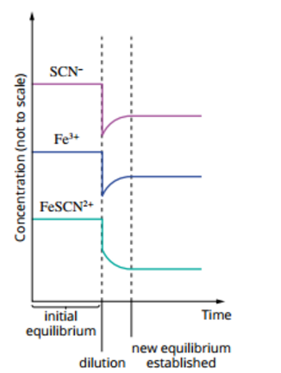

* Notice how SCN- has the largest initial concentration drop and the FeSCN2+ the smallest drop. This is due to their different initial concentrations.
* Stoichiometric proportions are then used to graph the transition back to equilibrium.
* In this example it is 1:1:1

